 | Full (Ref)  N=7,019 | Marginal  N=1,136 | Low  N=1,218 | Very Low  N=721 | Overall  (N=10,094)
 | N (%) | N (%) | N (%) | N (%) | N (%)
Sex
Male | 3509 (50) | 533 (46.9) | 569 (51.5) | 569 (46.7) | 4,954 (49.1)
Female | 3,510 (50.0) | 603 (53.1) | 649 (53.3) | 378 (52.4) | 5,140 (50.9))
Age (years) | 49 (19) | 42 (18) | 42 (17) | 42 (16) | 47 (19)
Race/Ethnicity
NH White | 3,412 (48.6) | 345 (30.4) | 318 (26.1) | 250 (34.7) | 4,325 (42.8)
NH Black | 1,441 (20.5) | 297 (26.1) | 331 (27.2) | 194 (26.9) | 2,263 (22.4)
Mexican-American | 868 (12.4) | 267 (23.5) | 294 (24.1) | 139 (19.3) | 1,568 (15.5)
Other Hispanic | 520 (7.4) | 126 (11.1) | 165 (13.5) | 95 (13.2) | 906 (9.0)
Other, incl. Multi-Racial | 778 (11.1) | 101 (8.9) | 110 (9.0) | 43 (6.0) | 1,032 (10.3)
Highest Educational Attainment
Less than 9th Grade | 1,382 (19.7) | 396 (34.9) | 504 (41.4) | 284 (39.4) | 2,566 (25.4)
High School Graduate or Equivalent | 1,730 (24.6) | 320 (28.2) | 327 (26.8) | 197 (27.3) | 2,574 (25.5)
Some College | 1,939 (27.6) | 313 (27.6) | 303 (24.9) | 210 (29.1) | 2,756 (27.4)
College or Above | 1,968 (28.0) | 107 (9.4) | 84 (6.9) | 30 (4.2) | 2,189 (21.7)
Poverty Income Ratio
Low Poverty | 993 (14.1%) | 397 (34.9%) | 528 (43.3%) | 375 (52.0%) | 2,293 (22.7%)
Near Poverty | 1,560 (22.2%) | 405 (35.7%) | 458 (37.6%) | 262 (36.3%) | 2,685 (26.6%)
Middle Income | 1,085 (15.5%) | 178 (15.7%) | 127 (10.4%) | 53 (7.4%) | 1,443 (14.3%)
Upper-Middle Income | 1,679 (23.9%) | 124 (10.9%) | 91 (7.5%) | 27 (3.7%) | 1,921 (19.0%)
High Income | 1,702 (24.2%) | 32 (2.8%) | 14 (1.1%) | 4 (0.6%) | 1,752 (17.4%)
Cycle Year
2005–2006 | 1,179 (16.8) | 154 (13.6) | 148 (12.2) | 70 (9.7) | 1,551 (15.4)
2007–2008 | 1,313 (18.7) | 175 (15.4) | 168 (13.8) | 93 (12.9) | 1,749 (17.3)
2009–2010 | 1,246 (17.8) | 197 (17.3) | 234 (19.2) | 148 (20.5) | 1,825 (18.1)
2011–2012 | 1,109 (15.8) | 195 (17.2) | 192 (15.8) | 127 (17.6) | 1,623 (16.1)
2013–2014 | 1,203 (17.1) | 199 (17.5) | 218 (17.9) | 138 (19.1) | 1,758 (17.4)
2015–2016 | 969 (13.8) | 216 (19.0) | 258 (21.2) | 145 (20.1) | 1,588 (15.7)

Table 1: Unweighted Demographic Characteristics of the Analytic Study Population
- Unweighted descriptive statistics count (frequency) and proportion (percentage) per food security category reported.

Study Population
A total of 10,094 adults were included in the final analytic study (Table 1). Participants were approximately evenly distributed by sex (male 49.1%, female: 50.9%). The median age was 47 years overall; adults with reduced food security (marginal, low and very low) were on average younger (n=42 years) than those with high food security (n=49 years). Non-Hispanic White adults were the largest racial/ethnic group overall (42.8%), followed by Non-Hispanic Black (22.4%) and Mexican American (15.5%). but were distributed differently across food security categories. Among adults with low food security, non-Hispanic Black (27.2%) and Mexican- American (24.1%) participants represented the largest proportions, whereas non-Hispanic White adults remained the largest group in high, marginal and very low categories. Participants with marginal, low and very low security had lower educational attainment, wigh a higher proportion having less than 9th grade (marginal: X%, low: X%, very low: X%) compared with adults with high food security (19.7%). Similarly, adults with reduced food security were more likely to live in low- or near-poverty households compared with adults with high food security.

Table 2: Detection Frequency and Distribution of Urinary Phenol Concentrations (ng/mL)

Urinary Metabolite | Abbreviation | %>LOD | 25th | GM | 75th
Bisphenol A | BPA | 92% | 0.69 | 1.52 | 3.10
2-Hydroxy-4-metoxybenzophenone | Benzophenone-3 | 96% | 4.71 | 21.05 | 76.71
2,4,4’-Trichloro-2’-hydroxyphenyl ether | Triclosan | 75% | 1.80 | 12.22 | 49.40
Ethyl paraben | EPB | 50% | 0.71 | 2.51 | 6.70
Methyl paraben | MPB | 99% | 13.33 | 51.21 | 192.50
Propyl paraben | PPB | 95% | 1.11 | 6.72 | 40.90
- %>LOD represents the limit of detection of phenol metabolite concentrations. Values below the detection limit are imputed as LOD $\sqrt{2}$by NHANES. The 25th and 75th percentiles are log-transformed. GM represents the geometric mean.

Detection Frequency and Distribution
Tabe 2 shows the detection frequencies and distribution of the six urinary phenol metabolites. Most urinary phenol metabolite concentrations had detection frequencies 90% of higher with the exception of ethyl paraben (50%) and triclosan (75%). Methyl paraben had the highest geometric mean of 51.21 ng/mL, while Bisphenol A was the lowest (geometric mean of 1.52 ng/mL). All phenols were positively correlated, with modest correlations between methyl paraben and propyl paraben (Spearman ρ= 0.82). (Supplemental Figure 2).

Figure 1: Household Food Security Associations with Urinary Phenol Concentrations
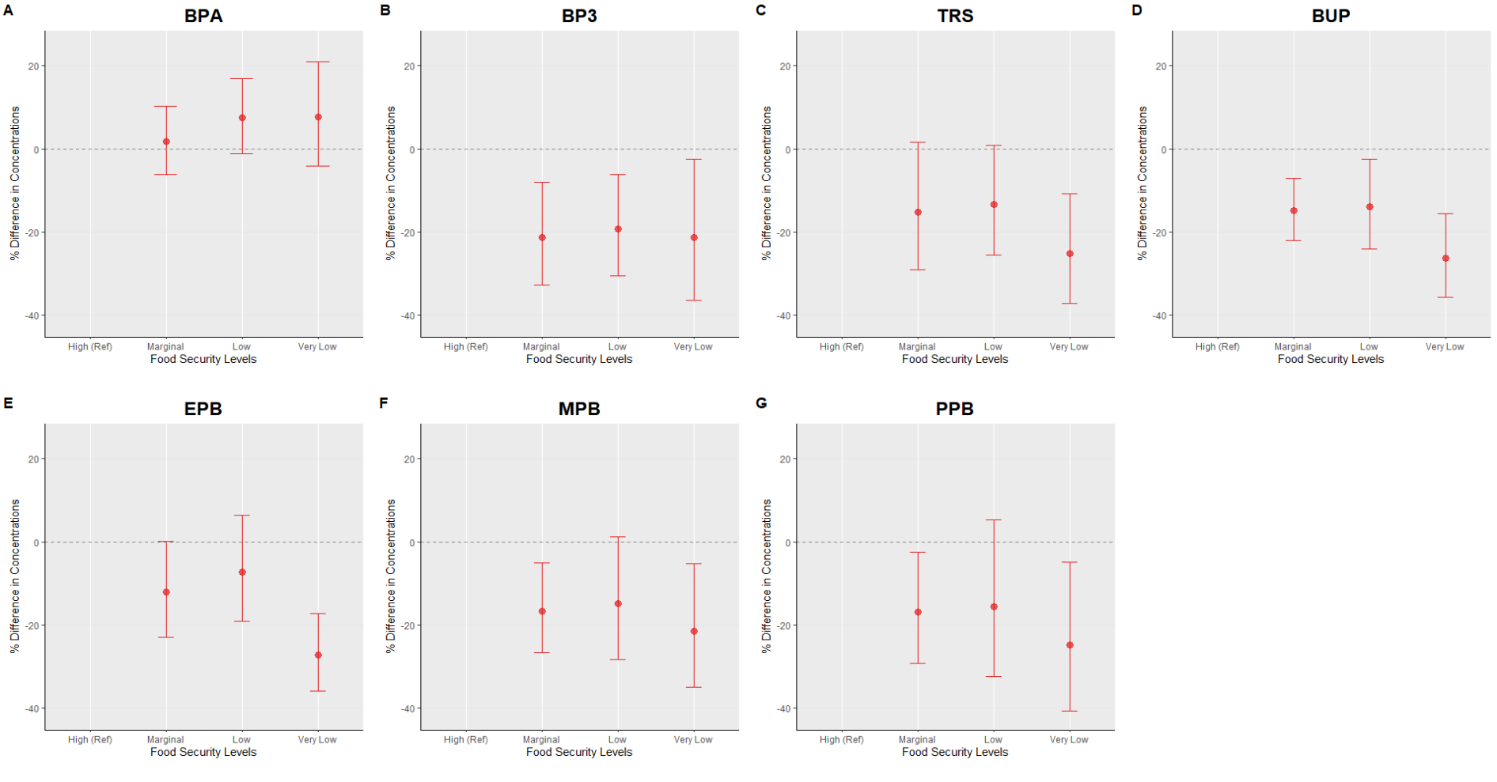
- Panels A–G represent adjusted percent differences in urinary phenol metabolite concentrations. Reference is High Food Secure. Circles represent estimated percent differences; bars represent 95% confidence intervals. All models are adjusted for age, sex education, race/ethnicity, poverty-income ratio, cycle year, and creatinine.

Table 3: Adjusted Linear Regression: Self-Reported Food Security Status and Urinary Phenol Metabolites

Phenol Metabolite | Food Security Level | % Difference | 95% LCI 95% UCI |  | P-Value
BPA | High (Ref)
 | Marginal | 1.80 | -5.91 | 10.15 | 0.65
 | Low | 7.53 | -1.27 | 17.12 | 0.09
 | Very Low | 7.61 | -4.48 | 21.23 | 0.22
BP3 | High (Ref)
 | Marginal | -19.82 | -31.68 | -5.91 | 0.01
 | Low | -17.40 | -29.05 | -3.84 | 0.01
 | Very Low | -19.55 | -35.27 | -0.02 | 0.05
TRS | High (Ref)
 | Marginal | -14.72 | -28.86 | 2.22 | 0.08
 | Low | -12.65 | -25.06 | 1.80 | 0.08
 | Very Low | -24.46 | -36.76 | -9.77 | 0.00
BUP | High (Ref)
 | Marginal | -14.08 | -21.33 | -6.15 | 0.00
 | Low | -12.94 | -23.29 | -1.18 | 0.03
 | Very Low | -25.49 | -34.95 | -14.66 | 0.00
$$EPB$$ | High (Ref)
 | Marginal | -10.97 | -21.90 | 1.50 | 0.08
 | Low | -5.65 | -17.98 | 8.53 | 0.41
 | Very Low | -25.96 | -35.07 | -15.57 | 0.00
$$MPB$$ | High (Ref)
 | Marginal | -16.65 | -26.78 | -5.10 | 0.01
 | Low | -14.81 | -28.35 | 1.29 | 0.07
 | Very Low | -21.53 | -35.05 | -5.18 | 0.01
$$PPB$$ | High (Ref)
 | Marginal | -16.26 | -28.75 | -1.59 | 0.03
 | Low | -15.16 | -32.01 | 5.85 | 0.14
 | Very Low | -25.08 | -40.79 | -5.20 | 0.02
- Values are adjusted percent differences in urinary phenol metabolite concentrations (ng/mL) compared to the High Food Secure category (reference group) based on multivariable linear regression models. adjusted for age, gender, education, cycle year, race/ethnicity, poverty: income ratio and creatinine.
- 95% LCI= 95% lower confidence interval; 95% UCI= 95% upper confidence interval.
- Abbreviations: BPA =Bisphenol A; BP3 =Bbenzophenone-3; TRS = 2,4,4’-Trichloro-2’-hydroxyphenyl ether; BUP = butyl paraben; EPB = ethyl paraben; MPB = methyl paraben; PPB = propyl paraben.

Main Analysis

In creatinine adjusted models, reduced food security was associated with higher levels of BP3, TRS, and PPB compared to the reference. For instance, very low food security was associated with positive percent difference in BP3 (10.42%), TRS (27.84%) and PPB (20.60%) (Supplemental Table 1). Reduced food security was generally associated with negative percent differences for remaining compared to high food secure levels.
In adjusted analysis, several of these trends did not persist and food security was negatively associated with most urinary phenols indicating reduced food security was associated with lower metabolite levels compared to high food secure individuals. For BP3, monotonic decreases were observed across marginal, all estimates for food security levels were well below the high-food security reference and fairly similar, indicating substantially lower concentrations among marginal (-19.82%, [95% CI: -31.68%, 5.91%]), low (-17.40%, [95% CI: -29.05%, -3.84%]), very low (-19.55%, [95% CI: 35.27%, 0.02%]) food security participants. Benzophenone-3 (BP3) levels were lower among individuals with marginal (-19.8% [95% CI: -31.7%, 5.9%]), low (-17.4% [95% CI: -29.1%, -3.8%]), and very low (-19.6%[95% CI: 35.3%, 0.02%]) food security groups compared to participants with high food security. While estimates for triclosan , and all parabens similarly suggested lower levels with reduced food security status,

very low food security consistently showed the largest percent differences. Specifically, compared to individuals with high food security, very low food insecure individuals had significantly lower levels of triclosan (-24.46%, [95% CI: -36.76%, -9.77%]), ethyl paraben(-25.96%, [95% CI: -35.07%, -15.57%] , methyl paraben (-21.53%, [95% CI: -35.05%, -5.18%], and propyl paraben (-25.08%, [95% CI: -40.79%, -5.20%]. Additional associations with marginal food security for some not all parabens were observed. (Figure 1, Table 3). mIn contrast, BPA was the only urinary phenol with positive % differences, suggesting higher concentrations with decreasing food security; however, all CIs contained the null (Figure 1, Table 3)

Figure 2: Strata Specific Adjusted Linear Regression Plot: Self-Reported Food Security Status and Urinary Phenol Metabolites with Sex Interaction

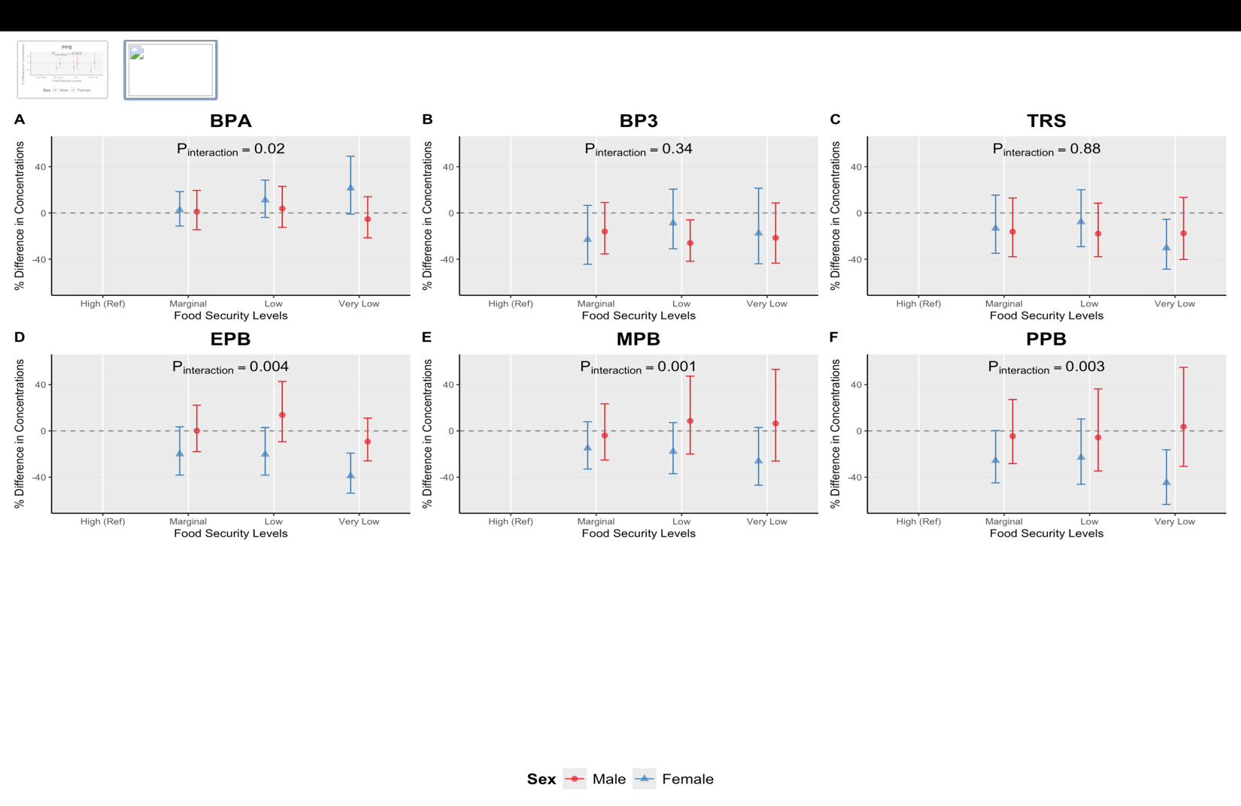

- Sex stratified adjusted percent differences (95% confidence intervals) in urinary phenol metabolite
- Concentrations across food security levels, estmated from multivariable linear regression models adjusted for age, race and ethnicity, education, survey cycle, poverty:income ratio and creatinine. High Food Secure is the reference group.
- P_{interaction} values are reported from food security*sex interaction models, where food security is modeled as continuous variable.

Effect Measure Modification by Sex

Next, we assessed potential effect measure modification by sex. There was evidence of interaction for BPA (p_{interaction}=0.02), and all parabens (ethyl (p_{interaction}<0.01), methyl (p_{interaction} <0.01), propyl (p_{interaction}<0.01). In stratum specific models, we estimated marginal means and reported percent differences.
For BPA estimates, both females and males exhibited positive differences with reduced food security exposure, although the association appeared to be slightly stronger among females. Specifically, females experiencing low 1(1.08%; 95% CI: -3.9%, 28.41%); and very low food security (very low: 21.45%; 95% CI: -1.04%, 49.05%) had higher BPA concentrations compared with females with high food security. Among males, estimates hovered around the null, and were slightly lower among very low males (X% [95%CI], compared to males experiencing high food security (-5.35%; 95% CI: -21.46%, 14.06%).

Percent differences for parabens remained mostly negative within stratum of sex, and associations were stronger amongst females. Among females experiencing high food security, ethyl paraben concentrations were lower for marginal ( 20.04% [95% CI: −38.24%, −3.51%]); low (20.29% [95% CI: −38.25%, −2.89%]) and very low (38.94% [95% CI: −53.86%, −19.21%) food secure females. Similar trends were observed for methyl paraben (marginal: (-14.99%; 95% CI:-33.01%, 7.87%; low: -17.85%; 95% CI: -37.03%, 7.18%; very low: -26.10%; 95 CI: -46.97%, 2.98%), and propyl paraben (marginal: (-25.71%; 95% CI:-44.96%, 0.27%%; low: -22.96%; 95% CI: -46.20%, 10.31%; very low: -44.82%; 95 CI: -63.63%, 16.28%). In contrast, among males with some but not all reduced food security categories, higher levels were observed for ethyl (low: X, insert), and methyl paraben (low: 8.59%, insert CI; very low: ) relative to the reference.

pinteraction

Figure 3: Strata-Specific Adjusted Linear Regression Plot: Self-Reported Food Security Status and Urinary Phenol Metabolites with Race and Ethnicity Interaction

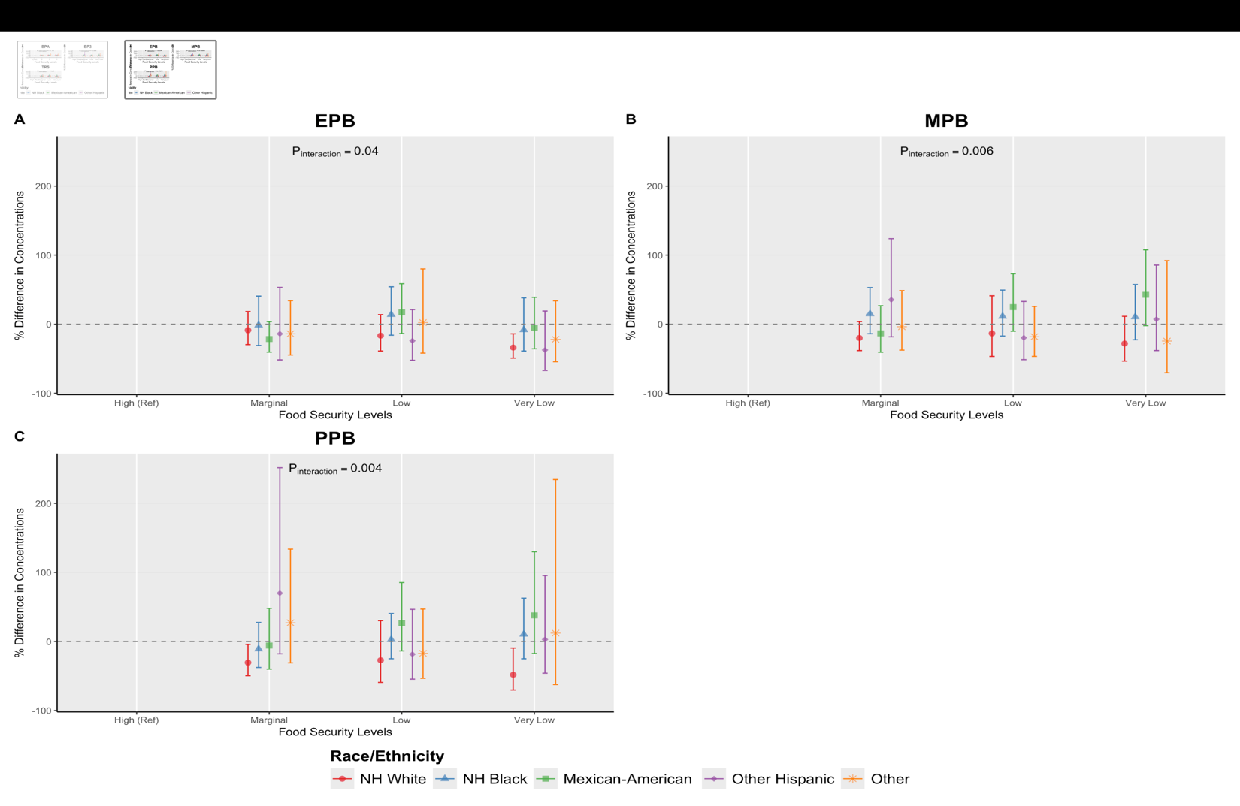

- Race stratified adjusted percent differences (95% confidence intervals) in urinary phenol metabolite concentrations across food security levels, estmated from multivariable linear regression models adjusted for age, sex, education, survey cycle, poverty:income ratio and creatinine. High Food Secure is the reference group.
- P_{interaction} values are reported from food security*race and ethnicity interaction models, where food security is modeled as continuous variable.
- NH White: Non Hispanic White; NH Black: Non-Hispanic Black

Effect Measure Modification by Race/Ethnicity

Finally, we assessed potential effect measure modification by race and ethnicity (Supplemental Tables 3-9). There was evidence of interaction in ethyl (p_{interaction}=0.04), methyl (p_{interaction}<0.01), and propyl parabens (p_{interaction} <0.01). Among non-Hispanic White individuals, reduced food security (marginal, low, and very low) was associated with lower levels of parabens. Non-Hispanic White individuals experiencing very low food secure participants had the largest negative difference (i.e lowest levels) compared to non-Hispanic White adults with high food security (e.g ethyl paraben concentrations: very low: X.X% [95% CI]).
In contrast, Mexican-American participants experiencing low or very low food security generally had higher levels of parabens. For instance, relative to Mexican-Americans with high food security, methyl parabens estimates were X.X% lower among Mexican-Americans experiencing low (insert estimate and CI) and X.X% lower among those experiencing very low: (insert estimate and CI) food security. Among non-Hispanic Black indivdiuals results were similar to those among non-Hispanic Black adults, with low food security generally showing the largest positive percent difference for ethyl (insert), methyl (insert) and propyl (insert) parabens. Among other Hispanic and Other-race adults, associations between reduced food security and paraben concentrations appeared to be positive for some, but not all parabens; however, results were mixed overall.

Supplemental Figure 1: Flowchart for NHANES Analytic Sample (2005-2016)
18,961 NHANES participants with available Phenols, food security and/or demographic data
Removed 5,754 participants who identified as children

13,207 Adult participants with (n=9 Phenols measured across relevant cycle years 2003-2016)

Removed 2,784 participants with missing creatinine, or exposure data

10,423 Adult participants with available creatinine and USDA FSSM questionnaire data

Edit: Removed 329 participants after excluding Bisphenol F and Bisphenol S from the urinary phenol list, participants missing urinary phenol concentration data, and the 2003–2004 cycle.

10,094 included in final analytic cohort (complete cases)

- Adult participants from the 2005–2016 NHANES cycles were included if demographic, food security, urinary Phenol, and urinary creatinine data were available. Participants were excluded for missing exposure values, missing urinary creatinine or urinary Phenol concentrations, and extreme outliers.
- Abbreviations: NHANES, National Health and Nutrition Examination Survey; FSSM, Food Security Survey Module; SD, standard deviation

Supplemental Figure 2: Spearman Correlation Matrix for Log Urinary Phenol Metabolites

- Spearman correlation coefficients are visualized, with larger and darker circles indicating stronger positive correlations between analytes. All correlations shown are positive, suggesting co-occurrence or shared sources among the measured phenol metabolites and related compounds.

Supplemental Figure 3: Strata-Specific Adjusted Linear Regression Plot: Self-Reported Food Security Status and Urinary Phenol Metabolites with Race and Ethnicity Interaction

- Race stratified adjusted percent differences (95% confidence intervals) in urinary phenol metabolite concentrations across food security levels, estmated from multivariable linear regression models adjusted for age, sex, education, survey cycle, poverty:income ratio and creatinine. High Food Secure is the reference group.
- P_{interaction} values are reported from food security*race and ethnicity interaction models, where food security is modeled as continuous variable.
- NH White: Non Hispanic White; NH Black: Non-Hispanic Black

Supplemental Table 1: Creatinine Adjusted: Self-Reported Food Security Status
O  Phenol Metabolite del | Term | Food Security Level | % Difference | 95% CI |  | P-Value
BPA | Intercept (Ref)  Marginal Food Secure  Low Food Secure  Very Low Food Secure | 1
BPA |  | 2 | 1.36 | -11.93 | 16.66 | 0.85
BPA |  | 3 | -9.85 | -19.51 | 0.97 | 0.07
BPA |  | 4 | -7.25 | -20.00 | 7.53 | 0.32
BP3 | Intercept (Ref)  Marginal Food Secure  Low Food Secure  Very Low Food Secure | 1
BP3 |  | 2 | -5.08 | -12.02 | 2.41 | 0.18
BP3 |  | 3 | -2.70 | -9.25 | 4.32 | 0.44
BP3 |  | 4 | 10.42 | -0.79 | 22.89 | 0.07
TRS | Intercept (Ref)  Marginal Food Secure  Low Food Secure  Very Low Food Secure | 1
TRS |  | 2 | 23.17 | 10.38 | 37.43 | 0.00
TRS |  | 3 | 18.18 | 7.75 | 29.61 | 0.00
TRS |  | 4 | 27.84 | 15.56 | 41.41 | 0.00
BUP | Intercept (Ref)  Marginal Food Secure  Low Food Secure  Very Low Food Secure | 1
BUP |  | 2 | 6.28 | -2.30 | 15.60 | 0.15
BUP |  | 3 | 11.59 | 0.93 | 23.38 | 0.03
BUP |  | 4 | 33.66 | 14.57 | 55.92 | 0.00
EPB | Intercept (Ref)  Marginal Food Secure  Low Food Secure  Very Low Food Secure | 1
EPB |  | 2 | -9.56 | -16.70 | -1.82 | 0.02
EPB |  | 3 | -17.65 | -24.29 | -10.43 | 0.00
EPB |  | 4 | -9.17 | -19.26 | 2.18 | 0.11
MPB | Intercept (Ref)  Marginal Food Secure  Low Food Secure  Very Low Food Secure | 1
MPB |  | 2 | 1.61 | -10.47 | 15.31 | 0.80
MPB |  | 3 | -6.53 | -15.22 | 3.05 | 0.17
MPB |  | 4 | -1.07 | -12.16 | 11.42 | 0.86
PPB | Intercept (Ref)  Marginal Food Secure  Low Food Secure | 1
PPB |  | 2 | 2.86 | -3.72 | 9.89 | 0.40
PPB |  | 3 | 6.08 | 0.09 | 12.43 | 0.05
PPB |  |  | 20.60 | 9.99 | 32.23 | 0.00
PPB | Very Low Food Secure | 4
- Values are unadjusted percent differences in urinary phenol metabolite concentrations (ng/mL) compared to the reference group (High (Ref)y Food Secure) based on multivariable linear regression models.
- 95% CI= 95% confidence interval.

Supplemental Table 2: Strata Specific Adjusted Linear Regression Full Table: Self-Reported Food Security Status and Urinary Phenol Metabolites with Sex Interaction
Sex | Phenol Metabolite | Food Security Level | % Difference (Interaction) | 95% CI
Male | BPA | High (Ref)
 |  | Marginal | 1.08 | -14.46 | 19.43
 |  | Low | 3.76 | -12.46 | 22.99
 |  | Very Low | -5.35 | -21.46 | 14.06
Female |  | High (Ref)
 |  | Marginal | 2.5 | -11.32 | 18.47
 |  | Low | 11.08 | -3.9 | 28.41
 |  | Very Low | 21.45 | -1.04 | 49.05
Male | BP3 | High (Ref)
 |  | Marginal | -16.08 | -35.4 | 9.02
 |  | Low | -26.04 | -41.81 | -5.99
 |  | Very Low | -21.55 | -43.36 | 8.66
Female |  | High (Ref)
 |  | Marginal | -23.03 | -44.39 | 6.54
 |  | Low | -8.78 | -31 | 20.6
 |  | Very Low | -17.51 | -43.95 | 21.41
Male | TRS | High (Ref)
 |  | Marginal | -16.23 | -37.84 | 12.91
 |  | Low | -17.87 | -37.81 | 8.47
 |  | Very Low | -17.63 | -40.19 | 13.44
Female |  | High (Ref)
 |  | Marginal | -13.31 | -34.9 | 15.43
 |  | Low | -7.74 | -29.12 | 20.09
 |  | Very Low | -30.31 | -48.6 | -5.52
Male | BUP | High (Ref)
 |  | Marginal | -0.83 | -14.6 | 15.17
 |  | Low | 2.28 | -12.01 | 18.89
 |  | Very Low | 5.93 | -11.74 | 27.14
Female |  | High (Ref)
 |  | Marginal | -24.64 | -37.05 | -9.77
 |  | Low | -24.73 | -41.24 | -3.58
 |  | Very Low | -46.55 | -59.43 | -29.59
Male | $$EPB$$ | High (Ref)
 |  | Marginal | 0.12 | -17.97 | 22.2
 |  | Low | 13.78 | -9.33 | 42.78
 |  | Very Low | -9.31 | -25.94 | 11.07
Female |  | High (Ref)
 |  | Marginal | -20.04 | -38.24 | 3.51
 |  | Low | -20.29 | -38.25 | 2.89
 |  | Very Low | -38.94 | -53.86 | -19.21
Female | $$MPB$$ | High (Ref)
 |  | Marginal | -3.93 | -25.21 | 23.42
 |  | Low | 8.59 | -19.99 | 47.37
 |  | Very Low | 6.41 | -26.1 | 53.22
Male |  | High (Ref)
 |  | Marginal | -14.99 | -33.01 | 7.87
 |  | Low | -17.85 | -37.03 | 7.18
 |  | Very Low | -26.1 | -46.97 | 2.98
Female | $$PPB$$ | High (Ref)
 |  | Marginal | -4.53 | -28.3 | 27.13
 |  | Low | -5.65 | -34.7 | 36.34
 |  | Very Low | 3.64 | -30.68 | 54.94
Male |  | High (Ref)
 |  | Marginal | -25.71 | -44.96 | 0.27
 |  | Low | -22.96 | -46.2 | 10.31
 |  | Very Low | -44.82 | -63.63 | -16.28

Supplemental Table 3: Strata Specific Adjusted Linear Regression Full Table: Self-Reported Food Security Status and Urinary Bisphenol A Phenol Metabolites with Race and Ethnicity Interaction

Race/Ethnicity Category | Model | Food Security Contrast | % Difference | % Lower | % Upper | P-Value
NH White | BPA | High (Ref)
 |  | Marginal | 7.19 | -9.91 | 27.53 | 0.72
 |  | Low | 9.41 | -8.42 | 30.71 | 0.54
 |  | Very Low | 13.96 | -11.85 | 47.32 | 0.54
NH Black |  | High (Ref)
 |  | Marginal | -5.26 | -18.24 | 9.77 | 0.77
 |  | Low | 1.08 | -13.76 | 18.47 | 1.00
 |  | Very Low | -0.25 | -15.08 | 17.17 | 1.00
Mexican-American |  | High (Ref)
 |  | Marginal | -4.11 | -22.52 | 18.67 | 0.95
 |  | Low | 0.14 | -14.43 | 17.20 | 1.00
 |  | Very Low | -11.54 | -37.31 | 24.84 | 0.78
Other Hispanic |  | High (Ref)
 |  | Marginal | -5.61 | -28.16 | 24.01 | 0.94
 |  | Low | -5.23 | -24.30 | 18.65 | 0.92
 |  | Very Low | 2.56 | -31.39 | 53.32 | 1.00
Other |  | High (Ref)
 |  | Marginal | -6.79 | -31.10 | 26.10 | 0.93
 |  | Low | 36.95 | -16.26 | 123.98 | 0.34
 |  | Very Low | 26.41 | -18.81 | 96.82 | 0.50
- Values represent percent differences for Food Security Level × Race and Ethnicity interaction terms, showing strata-specific estimates. Within each race and ethnicity group (NH White, NH Black, Mexican American, Other Hispanic, Other, ) estimates indicate the percent difference for each food security level compared with the reference. Estimates are derived from multivariable linear regression models adjusted for age, sex, education, cycle year, poverty: income ratio and creatinine.
- NH White: Non Hispanic White; NH Black: Non-Hispanic Black
- 95% CI = 95% confidence interval

Supplemental Table 4: Strata Specific Adjusted Linear Regression Full Table: Self-Reported Food Security Status and Urinary Benzophenone-3 Phenol Metabolites with Race and Ethnicity Interaction

Race/Ethnicity Category | Model | Food Security Contrast | % Difference | % Lower | % Upper | P-Value
NH White | BP3 | High (Ref)
 |  | Marginal | -28.70 | -48.72 | -0.87 | 0.04
 |  | Low | -27.92 | -48.98 | 1.84 | 0.07
 |  | Very Low | -33.44 | -58.81 | 7.56 | 0.12
NH Black |  | High (Ref)
 |  | Marginal | -15.93 | -41.65 | 21.12 | 0.59
 |  | Low | -2.98 | -31.62 | 37.65 | 1.00
 |  | Very Low | 11.06 | -27.60 | 70.36 | 0.92
Mexican-American |  | High (Ref)
 |  | Marginal | -2.94 | -36.16 | 47.57 | 1.00
 |  | Low | 1.00 | -27.35 | 40.41 | 1.00
 |  | Very Low | 3.52 | -38.55 | 74.39 | 1.00
Other Hispanic |  | High (Ref)
 |  | Marginal | 45.85 | -24.66 | 182.35 | 0.44
 |  | Low | 2.52 | -37.93 | 69.31 | 1.00
 |  | Very Low | -9.51 | -53.73 | 76.98 | 0.98
Other |  | High (Ref)
 |  | Marginal | -33.54 | -59.54 | 9.16 | 0.14
 |  | Low | -21.54 | -54.22 | 34.48 | 0.64
 |  | Very Low | -5.03 | -56.58 | 107.74 | 1.00
- Values represent percent differences for Food Security Level × Race and Ethnicity interaction terms, showing strata-specific estimates. Within each race and ethnicity group (NH White, NH Black, Mexican American, Other Hispanic, Other, ) estimates indicate the percent difference for each food security level compared with the reference. Estimates are derived from multivariable linear regression models adjusted for age, sex, education, cycle year, poverty: income ratio and creatinine.
- NH White: Non Hispanic White; NH Black: Non-Hispanic Black
- 95% CI = 95% confidence interval

Supplemental Table 5: Strata Specific Adjusted Linear Regression Full Table: Self-Reported Food Security Status and Urinary Triclosan Phenol Metabolites with Race and Ethnicity Interaction

Race/Ethnicity Category | Model | Food Security Contrast | % Difference | % Lower | % Upper | P-Value
NH White | TRS | High (Ref)
 |  | Marginal | -19.32 | -44.37 | 17.01 | 0.43
 |  | Low | -21.28 | -42.74 | 8.23 | 0.20
 |  | Very Low | -27.72 | -49.16 | 2.77 | 0.08
NH Black |  | High (Ref)
 |  | Marginal | 3.33 | -31.26 | 55.33 | 1.00
 |  | Low | -4.87 | -31.91 | 32.92 | 0.98
 |  | Very Low | -8.95 | -38.66 | 35.15 | 0.92
Mexican-American |  | High (Ref)
 |  | Marginal | -10.47 | -41.78 | 37.67 | 0.90
 |  | Low | 8.20 | -34.34 | 78.30 | 0.98
 |  | Very Low | -0.75 | -47.93 | 89.18 | 1.00
Other Hispanic |  | High (Ref)
 |  | Marginal | -12.86 | -57.72 | 79.59 | 0.96
 |  | Low | 8.17 | -50.51 | 136.40 | 0.99
 |  | Very Low | -25.50 | -58.93 | 35.15 | 0.56
Other |  | High (Ref)
 |  | Marginal | -15.42 | -55.96 | 62.43 | 0.90
 |  | Low | -28.70 | -61.22 | 31.08 | 0.46
 |  | Very Low | -60.86 | -83.14 | -9.11 | 0.02
- Values represent percent differences for Food Security Level × Race and Ethnicity interaction terms, showing strata-specific estimates. Within each race and ethnicity group (NH White, NH Black, Mexican American, Other Hispanic, Other, ) estimates indicate the percent difference for each food security level compared with the reference. Estimates are derived from multivariable linear regression models adjusted for age, sex, education, cycle year, poverty: income ratio and creatinine.
- NH White: Non Hispanic White; NH Black: Non-Hispanic Black
- 95% CI = 95% confidence interval

Supplemental Table 6: Strata Specific Adjusted Linear Regression Full Table: Self-Reported Food Security Status and Urinary Butyl Paraben Metabolites with Race and Ethnicity Interaction

Race/Ethnicity Category | Model | Food Security Contrast | % Difference | % Lower | % Upper | P-Value
NH White | BUP | High (Ref)
 |  | Marginal | -23.95 | -37.16 | -7.96 | 0.00
 |  | Low | -22.47 | -37.52 | -3.79 | 0.01
 |  | Very Low | -32.29 | -48.42 | -11.10 | 0.00
NH Black |  | High (Ref)
 |  | Marginal | -5.33 | -27.71 | 23.98 | 0.95
 |  | Low | -3.31 | -30.20 | 33.93 | 0.99
 |  | Very Low | -20.74 | -40.46 | 5.51 | 0.15
Mexican-American |  | High (Ref)
 |  | Marginal | -1.61 | -31.75 | 41.85 | 1.00
 |  | Low | 25.63 | -10.42 | 76.19 | 0.29
 |  | Very Low | -1.23 | -30.43 | 40.24 | 1.00
Other Hispanic |  | High (Ref)
 |  | Marginal | 11.36 | -40.68 | 109.06 | 0.97
 |  | Low | -24.56 | -49.68 | 13.09 | 0.26
 |  | Very Low | -31.89 | -55.71 | 4.73 | 0.10
Other |  | High (Ref)
 |  | Marginal | 7.27 | -36.14 | 80.19 | 0.98
 |  | Low | -14.83 | -42.98 | 27.20 | 0.72
 |  | Very Low | 5.63 | -49.97 | 123.05 | 1.00
- Values represent percent differences for Food Security Level × Race and Ethnicity interaction terms, showing strata-specific estimates. Within each race and ethnicity group (NH White, NH Black, Mexican American, Other Hispanic, Other, ) estimates indicate the percent difference for each food security level compared with the reference. Estimates are derived from multivariable linear regression models adjusted for age, sex, education, cycle year, poverty: income ratio and creatinine.
- NH White: Non Hispanic White; NH Black: Non-Hispanic Black
- 95% CI = 95% confidence interval

Supplemental Table 7: Strata Specific Adjusted Linear Regression Full Table: Self-Reported Food Security Status and Urinary Ethyl Phenol Metabolites with Race and Ethnicity Interaction

Race/Ethnicity Category | Model | Food Security Contrast | % Difference | % Lower | % Upper | P-Value
NH White | EPB | High (Ref)
 |  | Marginal | -8.68 | -29.52 | 18.34 | 0.79
 |  | Low | -16.56 | -38.83 | 13.81 | 0.42
 |  | Very Low | -33.81 | -49.12 | -13.90 | 0.00
NH Black |  | High (Ref)
 |  | Marginal | -1.33 | -30.77 | 40.62 | 1.00
 |  | Low | 13.88 | -15.89 | 54.18 | 0.67
 |  | Very Low | -8.10 | -38.85 | 38.11 | 0.95
Mexican-American |  | High (Ref)
 |  | Marginal | -21.44 | -40.49 | 3.71 | 0.11
 |  | Low | 17.21 | -13.39 | 58.63 | 0.51
 |  | Very Low | -5.39 | -35.55 | 38.87 | 0.98
Other Hispanic |  | High (Ref)
 |  | Marginal | -13.89 | -51.65 | 53.35 | 0.90
 |  | Low | -23.94 | -52.24 | 21.12 | 0.41
 |  | Very Low | -37.32 | -67.00 | 19.05 | 0.23
Other |  | High (Ref)
 |  | Marginal | -13.86 | -44.63 | 34.02 | 0.81
 |  | Low | 2.35 | -41.84 | 80.11 | 1.00
 |  | Very Low | -21.85 | -54.36 | 33.80 | 0.62
- Values represent percent differences for Food Security Level × Race and Ethnicity interaction terms, showing strata-specific estimates. Within each race and ethnicity group (NH White, NH Black, Mexican American, Other Hispanic, Other, ) estimates indicate the percent difference for each food security level compared with the reference. Estimates are derived from multivariable linear regression models adjusted for age, sex, education, cycle year, poverty: income ratio and creatinine.
- NH White: Non Hispanic White; NH Black: Non-Hispanic Black
- 95% CI = 95% confidence interval

Supplemental Table 8: Strata Specific Adjusted Linear Regression Full Table: Self-Reported Food Security Status and Urinary Methyl Paraben Metabolites with Race and Ethnicity Interaction

Race/Ethnicity Category | Model | Food Security Contrast | % Difference | % Lower | % Upper | P-Value
NH White | MPB | High (Ref)
 |  | Marginal | -19.89 | -38.16 | 3.77 | 0.12
 |  | Low | -13.26 | -46.67 | 41.08 | 0.87
 |  | Very Low | -27.98 | -53.43 | 11.37 | 0.20
NH Black |  | High (Ref)
 |  | Marginal | 14.92 | -13.72 | 53.06 | 0.58
 |  | Low | 11.32 | -17.07 | 49.43 | 0.77
 |  | Very Low | 10.52 | -22.45 | 57.50 | 0.88
Mexican-American |  | High (Ref)
 |  | Marginal | -13.25 | -40.63 | 26.75 | 0.75
 |  | Low | 24.69 | -10.20 | 73.13 | 0.29
 |  | Very Low | 42.53 | -2.18 | 107.69 | 0.07
Other Hispanic |  | High (Ref)
 |  | Marginal | 35.32 | -18.18 | 123.81 | 0.39
 |  | Low | -19.58 | -51.35 | 32.94 | 0.66
 |  | Very Low | 7.16 | -38.14 | 85.64 | 0.99
Other |  | High (Ref)
 |  | Marginal | -3.62 | -37.52 | 48.67 | 1.00
 |  | Low | -18.07 | -46.61 | 25.72 | 0.61
 |  | Very Low | -24.38 | -70.22 | 92.06 | 0.86
- Values represent percent differences for Food Security Level × Race and Ethnicity interaction terms, showing strata-specific estimates. Within each race and ethnicity group (NH White, NH Black, Mexican American, Other Hispanic, Other, ) estimates indicate the percent difference for each food security level compared with the reference. Estimates are derived from multivariable linear regression models adjusted for age, sex, education, cycle year, poverty: income ratio and creatinine.
- NH White: Non Hispanic White; NH Black: Non-Hispanic Black
- 95% CI = 95% confidence interval

Supplemental Table 9: Strata Specific Adjusted Linear Regression Full Table: Self-Reported Food Security Status and Urinary Propyl Phenol Metabolites with Race and Ethnicity Interaction

Race/Ethnicity Category | Model | Food Security Contrast | % Difference | % Lower | % Upper | P-Value
NH White | PPB | High (Ref)
 |  | Marginal | -30.53 | -49.58 | -4.29 | 0.02
 |  | Low | -27.15 | -59.22 | 30.15 | 0.48
 |  | Very Low | -48.19 | -70.35 | -9.46 | 0.01
NH Black |  | High (Ref)
 |  | Marginal | -10.84 | -37.63 | 27.46 | 0.83
 |  | Low | 2.65 | -24.99 | 40.49 | 1.00
 |  | Very Low | 10.44 | -25.02 | 62.69 | 0.90
Mexican-American |  | High (Ref)
 |  | Marginal | -5.81 | -40.05 | 47.98 | 0.99
 |  | Low | 26.54 | -13.62 | 85.37 | 0.37
 |  | Very Low | 37.84 | -17.37 | 129.92 | 0.35
Other Hispanic |  | High (Ref)
 |  | Marginal | 69.95 | -17.84 | 251.52 | 0.23
 |  | Low | -18.43 | -54.59 | 46.52 | 0.79
 |  | Very Low | 2.87 | -45.88 | 95.53 | 1.00
Other |  | High (Ref)
 |  | Marginal | 27.03 | -30.96 | 133.74 | 0.73
 |  | Low | -17.21 | -53.35 | 46.92 | 0.82
 |  | Very Low | 12.13 | -62.41 | 234.42 | 0.99
- Values represent percent differences for Food Security Level × Race and Ethnicity interaction terms, showing strata-specific estimates. Within each race and ethnicity group (NH White, NH Black, Mexican American, Other Hispanic, Other, ) estimates indicate the percent difference for each food security level compared with the reference. Estimates are derived from multivariable linear regression models adjusted for age, sex, education, cycle year, poverty: income ratio and creatinine.
- NH White: Non Hispanic White; NH Black: Non-Hispanic Black
- 95% CI = 95% confidence interval

